 



**SECOND EDITION**

DHAKA TUESDAY JUNE 4, 2024



Regd. No. DA 781

Vol. XXXIV No. 135

Jaishtha 21, 1431 BS

Zilqad 26, 1445 Hijri

16 Pages Plus Life Style : Tk 15.00

Mexico elects Sheinbaum as first woman president

### P7

Break the syndicates, not the dreams of migrants

### P8

England begin T20 World Cup defence today

### P11

Why tech workers must reskill, upskill in the age of AI

### P10

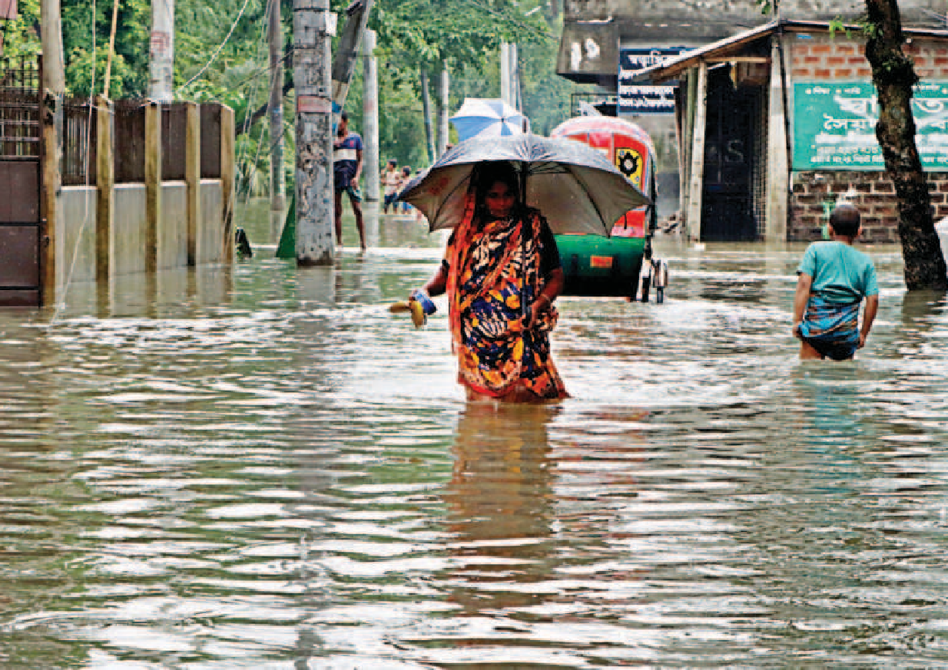Power, agriculture to drive up subsidies

**42,000**

**25,000**

*Probable

REJAUL KARIM BYRON *and*

ASIFUR RAHMAN

The subsidies and incentive expenditures in the upcoming budget are going to be more than that of the current fiscal year.

The subsidies are mainly increasing in the power, energy, and the agriculture sectors.

Even though the government plans to raise power tariffs four to five times a year, the highest subsidy allocation is likely to go towards the electricity sector.

**8,945**

**7,632**

Finance ministry officials said the increased subsidy allocation was largely due to the arrears in the power and agriculture sectors.

In the upcoming fiscal year, which begins on July 1, the subsidy allocation is likely to be Tk 1,12,000 crore, up from Tk 1,00,174 crore in the outgoing fiscal year.

Of the sum to be set aside for 2024-25, the power sector is likely to get Tk 42,000 crore. The government has earmarked Tk 35,000 crore for 2023-24.

Before 2021-22, the subsidy allocation for the power sector was between Tk 7,000 crore and Tk 9,000 crore.



SUBSIDY TREND IN BUDGET

*In crores of taka*

**1,12,000**

**96,770**

**1,00,174**

**57,445**

**38,262**

FY21

FY22

FY23

FY24

FY25*

**POWER SUBSIDY AGRICULTURE SUBSIDY TOTAL SUBSIDY**

**11,963**

**11,864**

**23,000**

**25,000**

Khondaker Golam Moazzem, research director at the Centre for Policy Dialogue, said the main reason

behind the rising subsidy allocation in FY25 is the higher energy prices in the international market and elevated capacity payments.

**35,000**

**18,299**

He said the government has planned to increase power tariffs

SEE PAGE 2 COL 4

###### An elderly woman wades through knee-deep water in Sylhet city’s Shahjalal neighbourhood yesterday afternoon. Due to the overflowing of rivers, overnight rains and mountain torrents, many areas in the city have gone under water, affecting at least 15,000 families. Due to the flooding, locals have been facing a shortage of food and clean water. Story on page 12. PHOTO: SHEIKH NASIR

PM likely to visit India on June 21

##### She may tour China on July 9



17,000 workers’ fate up in the air

Even with clearance, they could not go to Malaysia

Inflation hits seven-month high

Higher food prices largely to blame

# Fresh areas in Sylhet flooded after heavy rain

## Over 6 lakh people stranded in 761 villages

UNB,

*Dhaka*

JAMIL MAHMUD

Despite getting emigration clearance, around 17,000 aspirant migrant workers could not fly to Malaysia before the May 31 deadline due to alleged mismanagement in the recruitment process.

Their fates now hang in the balance.

“If the government wants to compensate the workers, it should return the exact amount they had to pay throughout the process, which could be higher than the government-fixed cost.”

Prof CR Abrar

MD ASADUZ ZAMAN

Inflation, fuelled by higher food prices, climbed 15 basis points to 9.89 percent in May from 9.74 percent a month earlier, figures from Bangladesh Bureau of Statistics showed yesterday.

This is the highest rise on the Consumer Price Index in seven months.

Food inflation surged 54 basis points to 10.76 percent from 10.22 percent while non-food inflation slipped 15 basis points to 9.19 percent from 9.34 percent in April.

In fiscal 2022-23, the average inflation rate was 9.02 percent, far higher than the average of 6 percent in recent years.

The Consumer Price Index grew by an average of 9.73 percent in the first 11 months of fiscal 2023-2024, which was 8.64 percent during the same period a year ago, BBS data showed.

“The persistent high inflation is continuously pushing the low-income groups against the wall,” said Mustafa K Mujeri, executive director of the Institute for Inclusive Finance and

SEE PAGE 2 COL 1

MINTU DESHWARA

The flood situation in Sylhet has further worsened owing to incessant rainfall since yesterday and the subsequent onrush of water from upstream, resulting in immense public sufferings.

As a result, fresh areas in the district, including a large part of the city, were inundated yesterday.

The newly inundated areas in the city include -- Jatarpur, Mendibagh,

Prime Minister Sheikh Hasina is likely to visit New Delhi and Beijing in June and July to deepen Bangladesh’s ties with Asia’s two leading economic powers.

The prime minister will likely pay an official visit to New Delhi on June 21- 22 and to Beijing on July 9-12, a senior Bangladeshi official told UNB.

The last bilateral engagement between Modi and Hasina was during the

SEE PAGE 6 COL 6

Victim’s family

‘leaves home fearing reprisal’

Says neighbour; police form probe body

STAR REPORT

The family of the woman, who died in police custody in Jashore on Sunday morning, padlocked their home and moved to a relative’s home after the incident,said a neighbour. 

Afroza Begum Afroza Begum, 40, died hours after being picked up by Abhaynagar police from her Nawapara village home. Her family accused policeof torture.

Visiting Afroza’s house yesterday, our Benapole

correspondent found it locked.

Her neighbour Nurul Islam Hawladar said the family moved to a relative’s house fearing reprisals from police.

The Daily Star could not reach Afroza’s husband Jalil Mollah and their two sons, Munna Mollah and Sabbir Molla, for comments as their phones were

SEE PAGE 2 COL 4

### 

Under the existing labour migration situation, the recruitment process for these workers had started much earlier and each had to pay hefty sums to secure jobs in Malaysia.

Many had to travel to Dhaka from other districts for different purposes, including pre-migration medical tests.

13

12

11

10

9

8

7

6

TREND OF INFLATION IN BANGLADESH *(in %)*

**NATIONAL**

**FOOD**

**NON-FOOD**

July’23

Aug

Sep

Oct

Nov

Dec

Jan’24

Feb

Mar

Apr

May

Some even made sure to be present at Hazrat Shahjalal International Airport in the capital on Friday, the day of the deadline.

SEE PAGE 2 COL 1

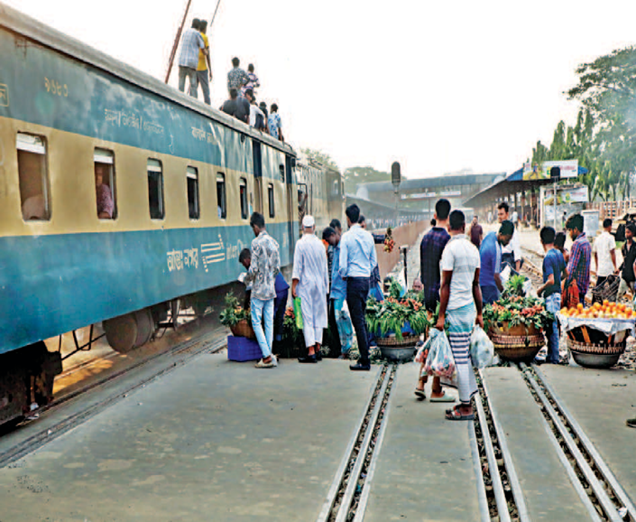Jamtala, Taltala, Sheikhghat, Kalapara, Majumdarpara, Laldigihipar, Dargamoholla, Munsipara, Hawapara, Nayorpool, Sonarpara, Baluchar, Mirer Maidan, Police Lines and Sagardighirpar. With the further deterioration in the flood situation, around six lakh people from 761 villages under 10 upazilas remain marooned, said Sheikh Russel

###### A train whizzes past fruit sellers who have placed themselves right on the lines near the Airport Railway Station, putting not only themselves but also their customers at risk. Multiple trains frequently pass through the station, opposite the Hazrat Shahjalal International Airport in the capital. The photo was taken yesterday.

###### PHOTO: PRABIR DAS

Hasan, deputy commissioner of Sylhet. Many roads have been submerged,

snapping communications at many places.

The ground floor of the Sylhet MAG Osmani Medical College Hospital has been inundated, said its Director Brig

SEE PAGE 2 COL 4

Benazir’s abuse of power a cause for grave concern

#### Says TIB, demands action against those who abetted, protected the former IGP

STAFF CORRESPONDENT

Transparency International Bangladesh yesterday expressed grave concerns over accumulation of substantial illegal wealth by a former police and Rab chief.

In a statement, it said the misuse of power by those who are in top positions creates “Frankenstein-like figures” such as Benazir Ahmed,

former inspector general

of police and it makes questionable the state’s mechanism to hold people accountable. The graft watchdog demanded legal action against those who abetted and protected the power abuser and fair compensation for those whose land was grabbed. According to media reports, the land in most cases was acquired by the former IGP through intimidation. Many of the landowners belong to minority.

SEE PAGE 6 COL 5